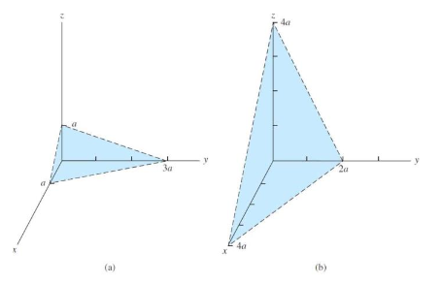Homework 1

1.

[021]

[121]

[112]

[313]

a

2a

**2a**

**2a**

2.

[110] ${\left(a^{2}+a^{2}\right)}^{1/2}=2^{1/2}a$

$a=πr^{2}$ $r=\sqrt{\frac{a}{π}}=\frac{\sqrt{a}}{\sqrt{π}}$

$\frac{2^{\frac{1}{2}}a}{2\frac{\sqrt{a}}{\sqrt{π}}}=2^{1/2}a*\frac{\sqrt{π}}{2\sqrt{a}}=\frac{2^{\frac{1}{2}}\sqrt{π}a}{2\sqrt{a}}=\frac{2^{\frac{1}{2}}\sqrt{π}\sqrt{a}}{2}=\frac{\sqrt{2πa}}{2}$

[111]

$\frac{\sqrt{2πa}}{2}+a$

3.